- For checking the error we can login to the pod and check the log.
Here in below case the application was down and we found the issue in pod log.
Ex: Project: 0234xlre-01-prod-axa-xl
Pods >> Pod details >> Logs
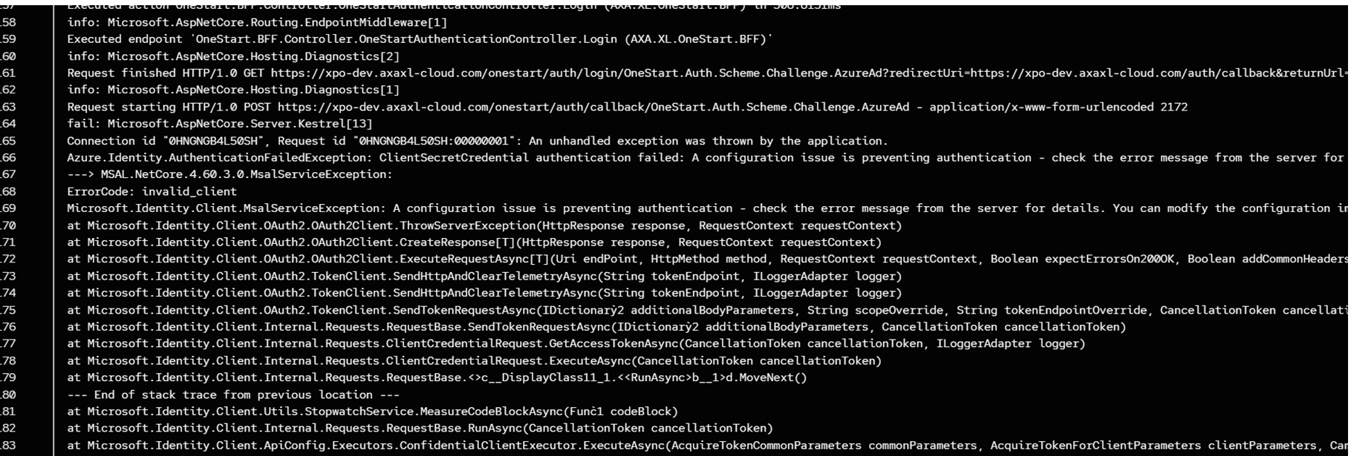

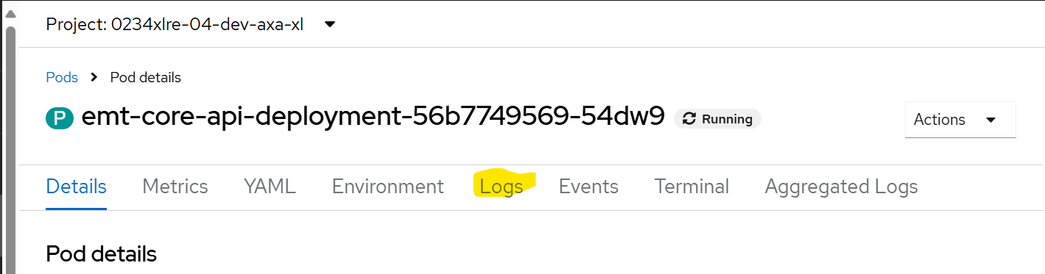

Application response:
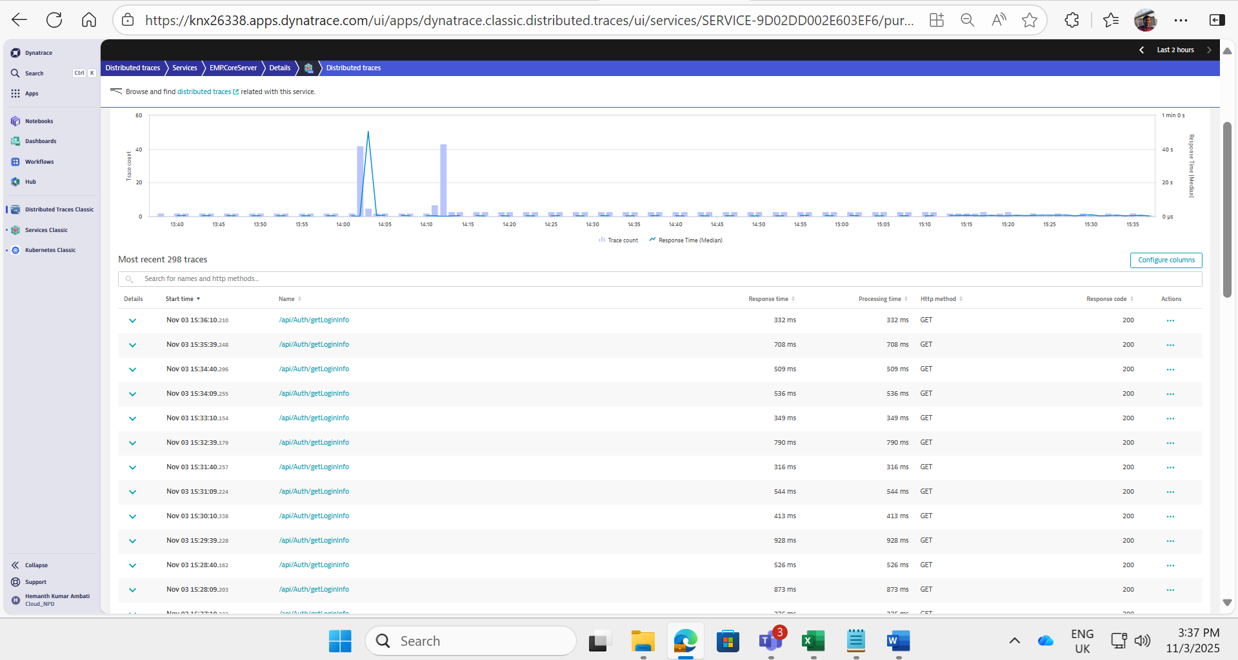

Infra Monitoring
Using Dynatrace:
Example:
URL: https://lru73743.apps.dynatrace.com/ui/apps/dynatrace.classic.kubernetes/ui/entity/CLOUD_APPLICATION_NAMESPACE-2D1C09F815FA4A32?gtf=-2h&gf=all&sessionId=6F3Qa3ad9H0ljO3

Kubernetes: openpaas-xlc-prd5
Namespaces: 0234xlre-01-prod-axa-xl
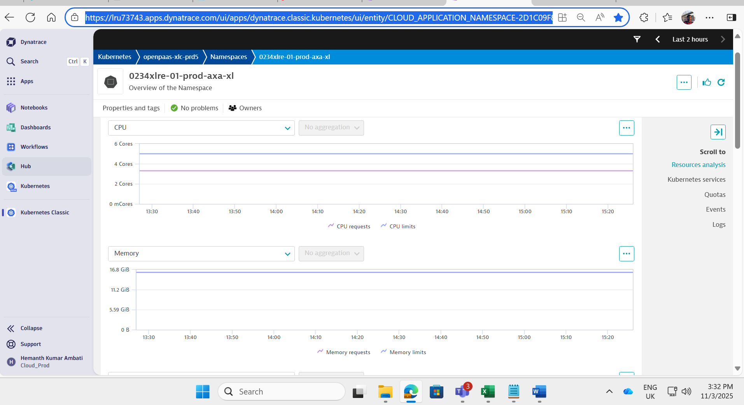

URL: https://knx26338.apps.dynatrace.com/ui/apps/dynatrace.classic.kubernetes/ui/entity/CLOUD_APPLICATION_NAMESPACE-DC921AB86CDBC8C8?gtf=-2h&gf=all&sessionId=vuVDLw6abKdF-Vvo
Kubernetes: openpaas-xlc-npd3
Namespaces: 0234xlre-04-dev-axa-xl

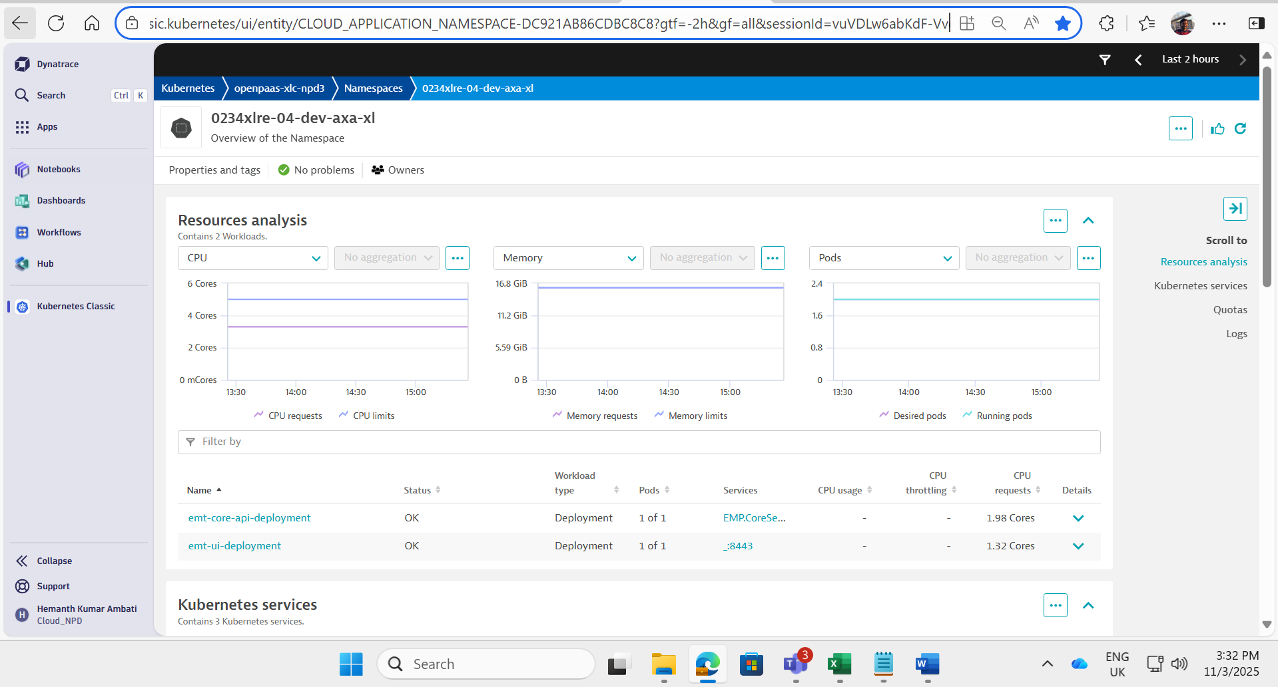

Pod Metrics Dashboard:
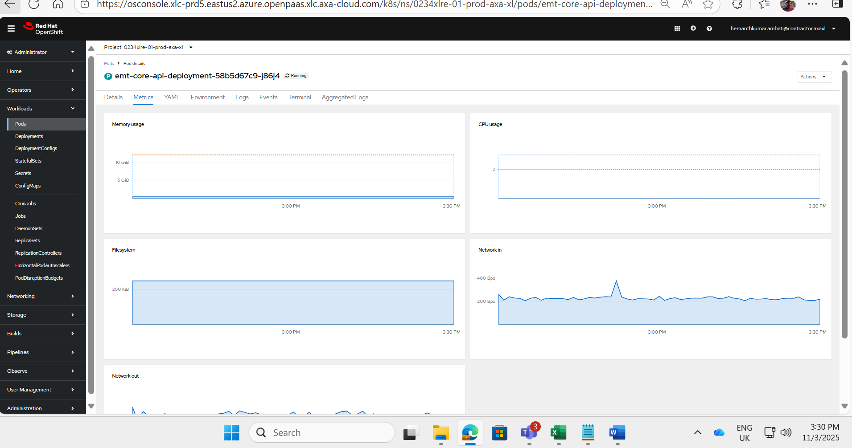

DB backup:
Team need to raise Silva request under CAS DBA catalogue and need to raise restore DB with 35 days.

